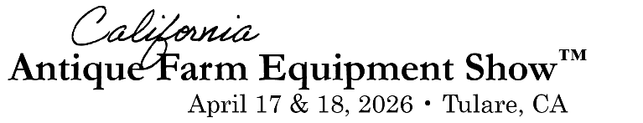


Parade Entry Form

Saturday & Sunday at 10:00 a.m.
(This form is for both days unless you misplace your number)

Owner/Primary Driver: Driver’s License Number:
Additional Driver: Driver’s License Number:
Name of Insurance Company: Policy Number:
City: State:
Email Address: Day(s) Entering Parade: Saturday Sunday
Type of Equipment (Make):
Year: Model:
Description:
Return this form to the Parade Booth by 8:00 a.m. on Saturday
Anyone operating machinery must have a valid driver’s license

Dinner Reservations

Steak Dinner and Entertainment in Farm Credit Dairy Center – Seat Reservation
Reserved seats available for groups of 8 or more only.

Saturday, April 18 | 5:00 p.m. Social Hour | 6:00 p.m. Dinner

Reservation Name:

Number of Seats: Phone: Email:

